**CMPG 311 Lab1-Assignment**

**By: T Maphike 24851027**

1. Use the installed **MySQL** in the **Given Folder** to create the database

**BidvestBank** which includes the following tables: NB – Submit all your code and answers via the **Github classroom URL**

**https://classroom.github.com/a/JbzRao2Q**

**Creating Database**

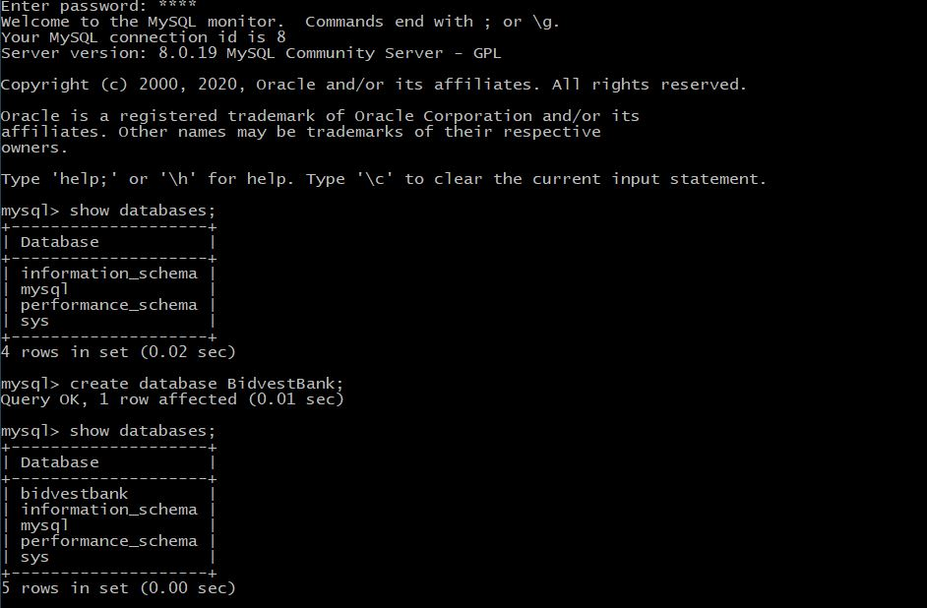

**Create tables**

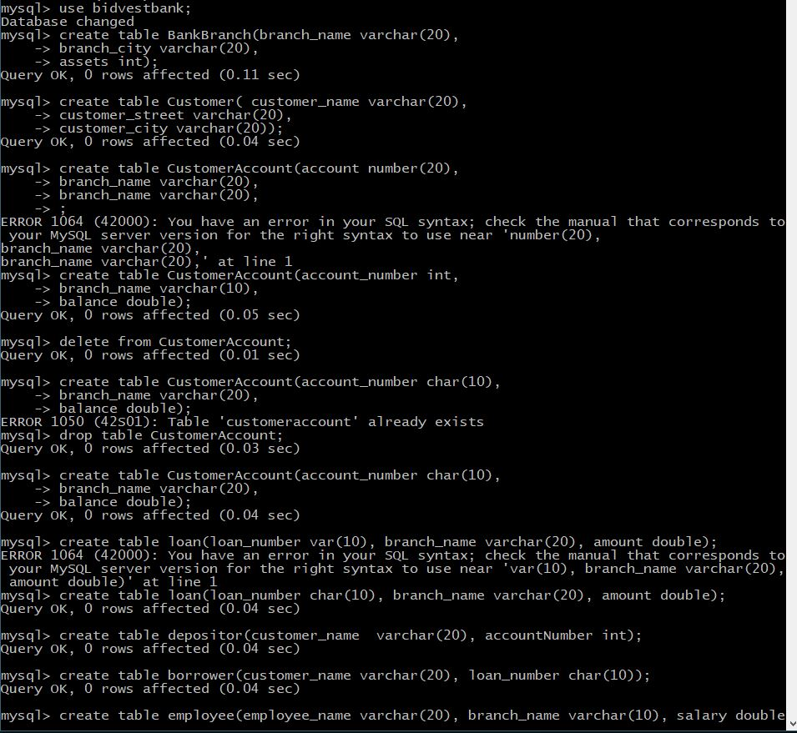

Show tables

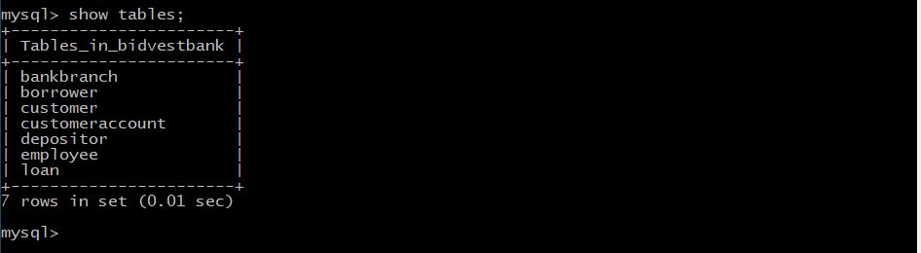

2. For all the above tables identify which of the attributes can be used as primary keys and assign primary keys to those tables.

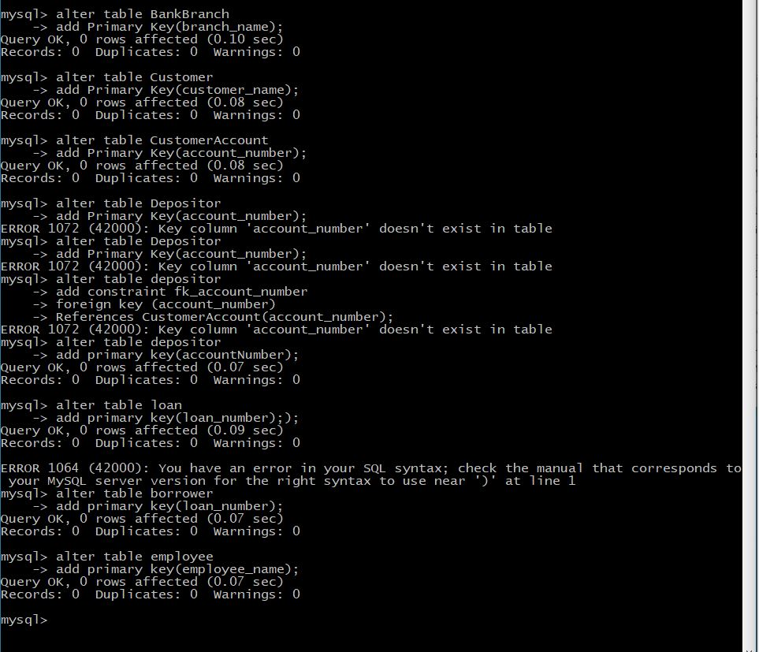

3. Populate all the tables that you created in question two with the following values:

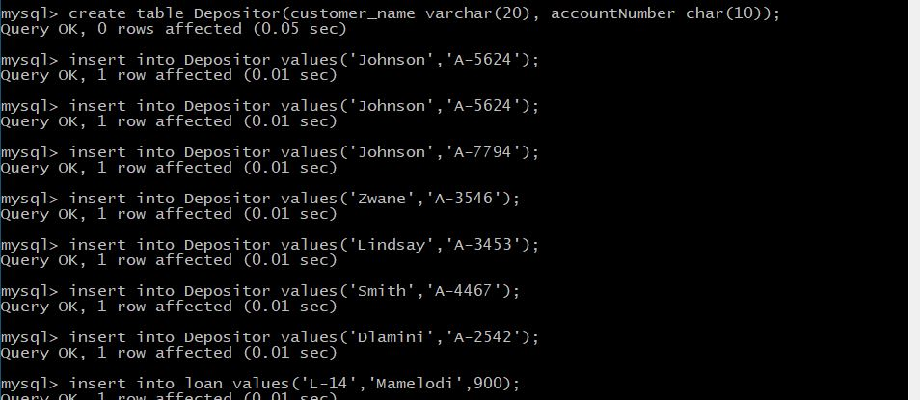

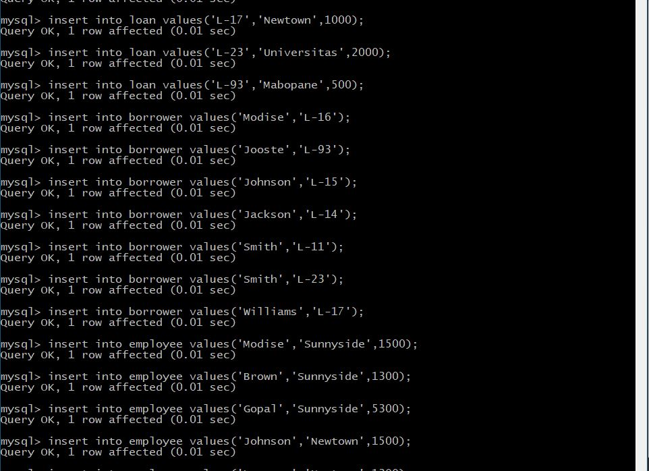

4. Perform the following queries on the **BidvestBank** database and show the screenshot of each query.

**i)** Find all customer accounts whose balance is smaller than **R700.**

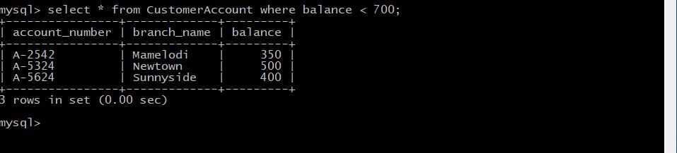

**ii)** Find all name of customers whose city is in **Johannesburg.**

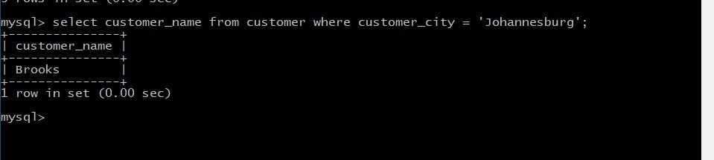

iii) Find all employees whose salary is greater than **R1500** and working branch is not

**Newtown.**

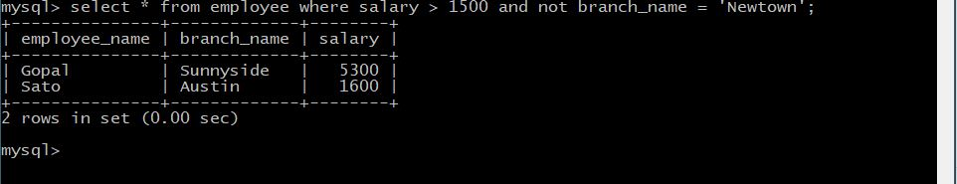

iv) Calculate the average salary of all employees and show the average salary as

**“avg_salary”**

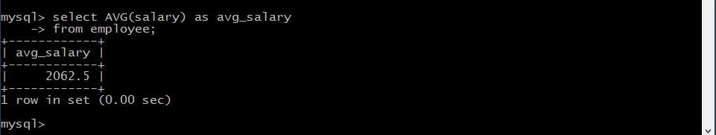

v) Display the bank with the largest number of **Assets**.

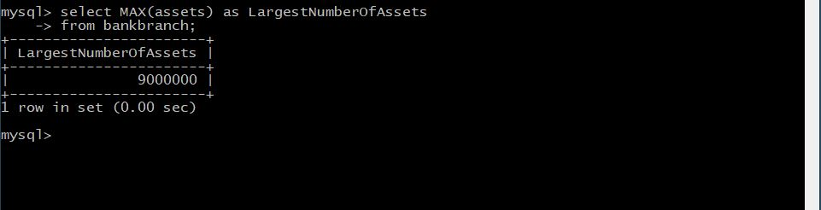

5. Provide the **SQL code** which can utilize **BidvestBank** database to provide the following:

i) Display the names of all employees who work in **Sunnyside** branch.

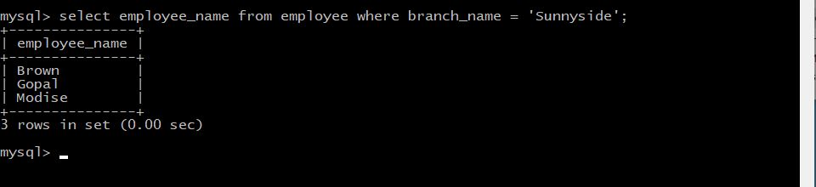

ii) Display the **borrower** table.

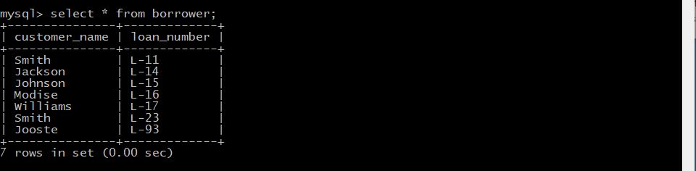

iii) Find the account number for all accounts where the balance is greater than

**R900.**



iv) Find the account number and balance for all accounts from **Newtown** where the balance is greater than **R600**.

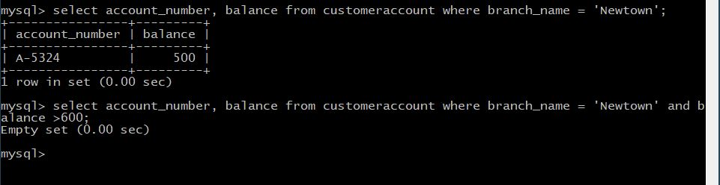

v) Display the branch name and assets from all branches.

